TASK 12 — Prompt Evaluation, Comparison and Refinement using LLM Responses
AIM
To design multiple prompts for the same text-generation task, evaluate their LLM outputs using predefined criteria, select the best-performing prompt, and refine it to improve the final response.
PROCEDURE
1. Select a text-generation task.
2. Design multiple prompts with different levels of detail.
3. Submit each prompt to the LLM and collect the responses.
4. Evaluate each response using relevance, accuracy, completeness, clarity, and format adherence.
5. Assign scores using a common evaluation scale.
6. Identify the best-performing prompt.
7. Refine the selected prompt by adding missing context, constraints, validation rules, and output formatting.
8. Generate the final response using the refined prompt and compare it with the original output.
PROMPT
PROMPT A:
Write an email requesting leave because I am sick.
PROMPT B:
Write a professional email to a college faculty member requesting three days
of leave because I am suffering from fever. Include a subject, polite greeting,
reason, duration, request for approval, and formal closing.
PROMPT C:
ROLE: You are an expert professional communication writer.
TASK: Write a formal leave-request email to a college faculty member.
CONTEXT: The student has fever and requires three days of leave.
REQUIREMENTS:
- Include a professional subject line.
- Use a respectful greeting.
- Clearly state the reason and duration.
- Politely request approval.
- Mention that missed academic work will be completed.
- End with a professional closing.
CONSTRAINTS:
- 100–150 words.
- Formal and grammatically correct English.
- No unnecessary information.
OUTPUT FORMAT:
Subject:
Greeting:
Body:
Closing:
REFINEMENT:
Before producing the final answer, verify that the subject, reason, duration,
approval request, closing, and word-count requirement are satisfied.

INPUT
Text-generation task:
Generate a professional leave-request email to a college faculty member because
the student has fever and requires three days of leave.
Evaluation criteria:
1. Relevance
2. Accuracy
3. Completeness
4. Clarity
5. Format adherence
Compare Prompts A, B, and C, select the best prompt, and refine it.

OUTPUT
OUTPUT — PLACE GENERATED OUTPUT IMAGE HERE
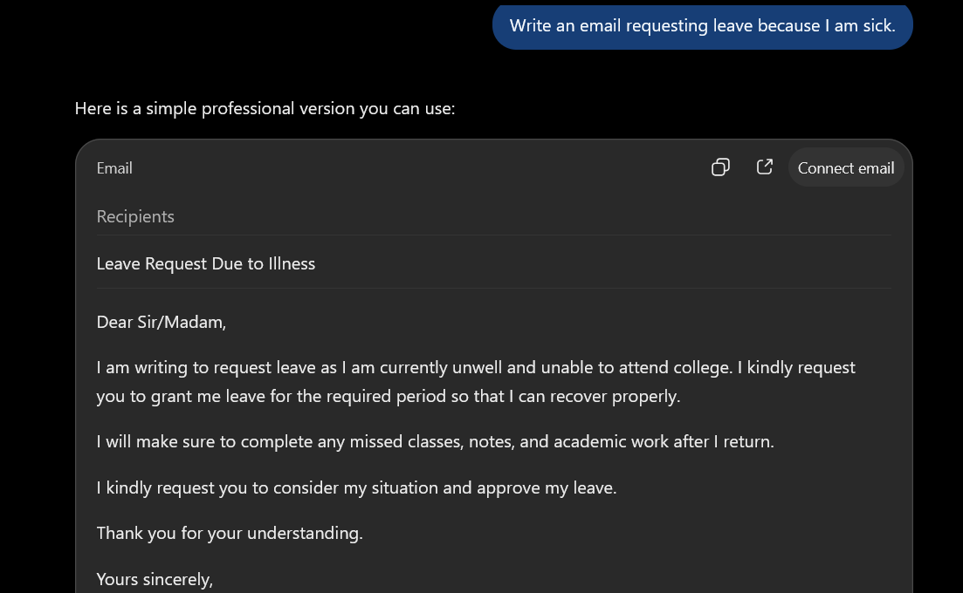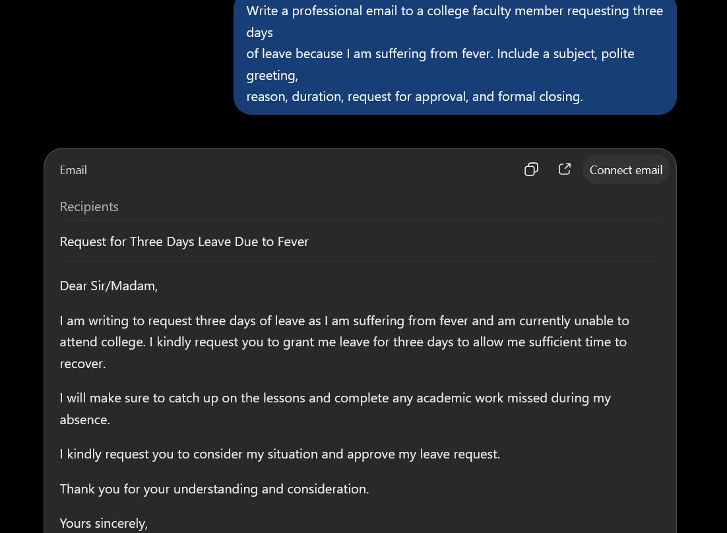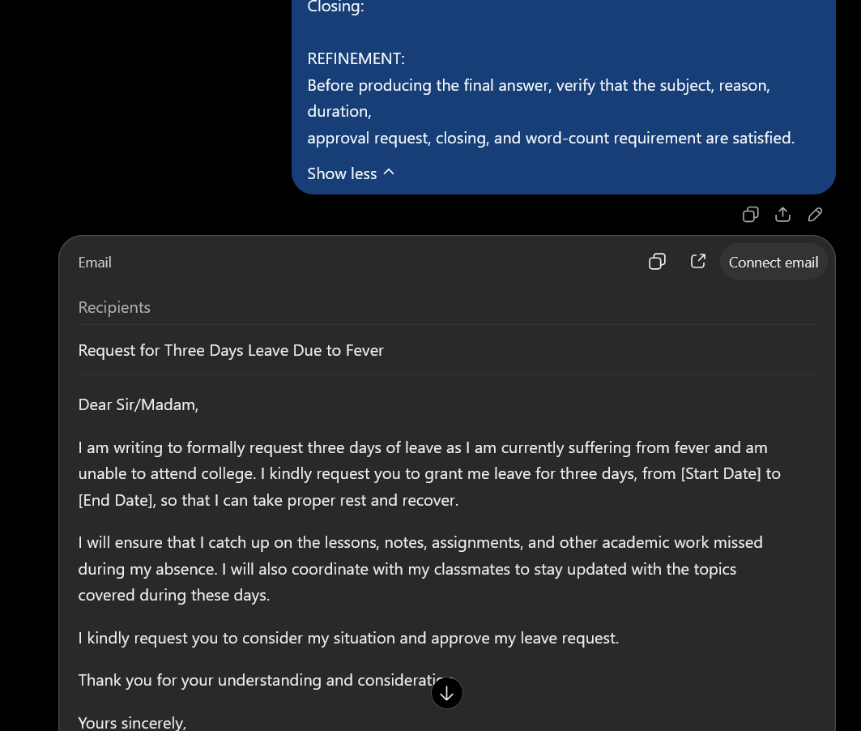

RESULT
The prompts are evaluated against predefined criteria, the best-performing prompt is identified, and the refined structured prompt is used to produce a clearer, more complete, and format-compliant response.

